**Interview Assignment:**

**Part 1:** Read about WCAG 2.0 Level A and Level AA Guidelines. Focus on techniques and failures.

**Part 2**:

Use Safari browser and Voiceover for the screen reader. Feel free to download any accessibility tool like Color contrast analyzer, axe.

Please test the following pages:

1. <https://www.neighborhood.bank/>

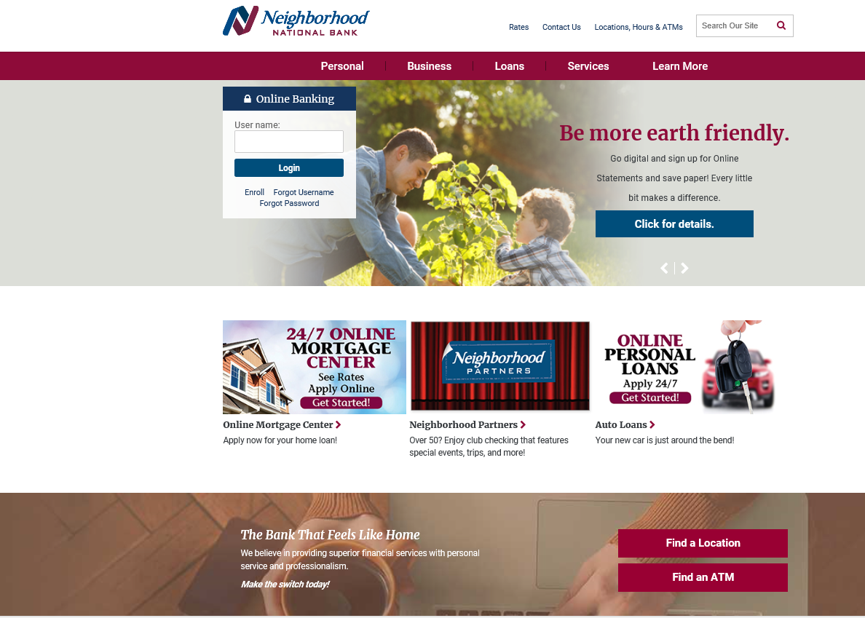

2. <https://neighborhood.myebanking.net/#/self-registration>

Click on let’s get started button so that it will direct you to form field as below:

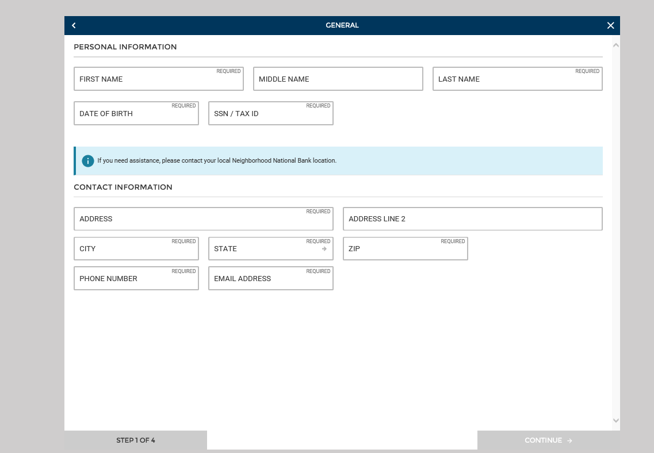

**Part 3:** Write the defects you found based on the WCAG 2.0 level A and AA guidelines**.**

**Part 4:** Map your defects to the guidelines that you think it fits the most and mention the severity.

**Example:**

1. Image on top of the page does not have alternative image. (1.1.1-Non text Content)(Low)